Checkmatries™

from

Clean Carry**©**

**User Manual**

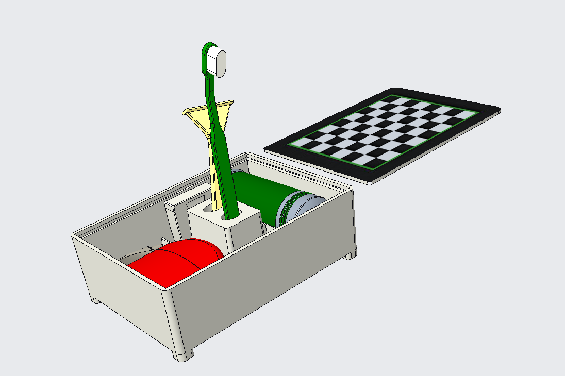

PLEASE READ THE FOLLOWING BEFORE USING YOUR CLEAN CARRY PRODUCT

**Clean Carry’s© Checkmatries™**

**Table of Contents**

Parts List…………………………………………………………………………3

User Instructions…………………………………………………………………4

Maintenance…………………………………………………………….………..5

Part Replacement/Recommendations……………………………………………7

Warranty Information……………………………………………………………9

Service Center/Contact Information……………………………………………..10

**Parts**

**Product:**

Clean Carry’s© Checkmatries™ are made up of 3 individual pieces for simpler use.

To assemble your Checkmatry™, refer to the image below, showing how our product is assembled. The dimensions are 7.25in x 5.25in x 2.37in. The material weight is 13 ounces, and the material volume is 20.33 in3.

**Not included with purchase:**

Your Clean Carry© product does hold the following items, but the following items do not come with your purchase:

(1) Toothbrush, (1) Toothpaste, (1) Comb, (1) Deodorant, (1) Razor, (1) Can of Shaving Cream, (1) Container of Floss, and Chess/Checker Pieces

**User Instructions**

Upon purchasing your Clean Carry© product, you will receive the Check boarded case with all parts, except for the lid and rubber seal assembled, allowing for easy use upon its arrival. Before assembly, check all parts arrived undamaged (no cracks, wear, etc.) To assemble, take the plastic off the rubber seal to reveal the sticky surface and place it evenly over the top of the case’s walls, where the lid will slide. Let the rubber seal set for 5-10 min, then slide in the lid.

Ensure that all parts of the case are adequately working; the lid is sliding correctly within its seal, and each of the toiletry's holder clips are connected firmly, preventing accidents during your travels. To use your Clean Carry© product to its highest potential, you must insert the following toiletries within their assigned slots (not included with purchase), a toothbrush, toothpaste, shaving foam or cream, a razor, deodorant, a comb, and a container of floss. All listed products must be bought as travel sized to fit into their appropriate locations of the Clean Carry© as seen in the image above. Simply place each item within the Clean Carry© and slide the lid into place, ensuring it is tightly sealed. You can now enjoy the convenience of our Checkmatries™ device and avert yourself from the worry of unorganized clutter upon arrival to your destination.

**Maintenance**

**Cleaning:**

Your Clean Carry© product should be cleaned regularly in between use to increase longevity of use. The case can be cleaned with:

* Noncorrosive cleaners
  + Soap and water
  + Peroxide / 10% Rubbing alcohol

Avoid cleaning your Clean Carry© product with:

* Corrosive cleaners
  + Bleach
  + Acetone

**Storage:**

When not using your Clean Carry© product, store in a cool, dry area to prevent mold or mildew build up from moisture, and to ensure longest use possible. Also avoid exposure to direct sunlight or heat, which could cause the materials to fade in color, or warp. Since the toiletry case is made of ABS plastic, it should ideally be stored in an area with a temperature between 60° F (16° C) to 80° F (27° C).

To avoid spills and leaks, keep your toiletries organized and tightly sealed within the case, preventing, but also making it easier to clean mishaps when necessary.

**Checking for damage:**

Regularly insect the case for any signs of wear or damage, such as scratches, chips, or discoloration, replacing the case or any parts as soon as possible to prevent further damage and ensure that your toiletries remain safe and secure during your travels.

When replacing any part, be sure to follow any instructions provided by the manufacturer to ensure that the replacement is done correctly, for example, if replacing the lid, you want to unscrew or detach existing lid and associated parts before attaching the replacement. By promptly replacing any damaged or lost parts, you can prolong the lifespan Clean Carry© product.

**Part Replacements / Recommendations**

Refer to image below to determine which part(s) need to be ordered.

**(1) Lid - $6.99**

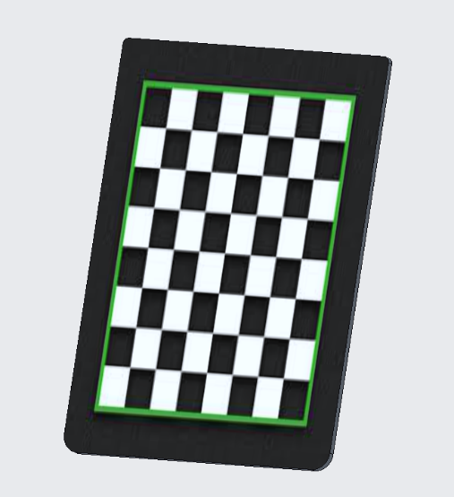

The lid may be assembled and used the same as the previous lid.

**(1) Lid Seal - $2.76**

The rubber seal is applied by its peel off sticker back to replace the damaged piece.

**(4) Feet - $1.99**

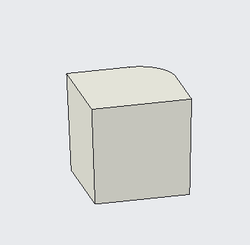

Sand the area around the damaged foot to flatten out the surface and prepare for glue. Apply provided glue to both the surface of the foot and the surface of the case, then hold together for 15-20 sec. Let sit for 20-30 min.

**Disclaimer:** If you don’t see the part you need, it is likely because it is nonreplaceable. Parts not listed above are fixed onto the case and would not be able to be restored. If this is the issue you are experiencing, please refer to the Warranty Information section of the User Manual for your next option.

**Warranty Information**

Customers experiencing issues with their products within five (5) months after the purchase date are entitled to free replacement parts or a replacement product, free of charge. There will be confirmation of damaged goods with a member of the Service Team, an online form to reorder the product, and the damaged part(s)/product will be returned to the store. Once all the steps have been completed, your new Clean Carry© product will be sent free of charge, including shipping and handling.

Customers experiencing issues with their product after five (5) months after the purchase date, replacement parts can be purchased through our Service Center found through our website: [CleanCarry.com](https://webpages.charlotte.edu/teid2/engr1202projectpage). To find the part needed and pricing, refer to the Part Replacements / Recommendations section of the User Manual.

**Free Trial:**

If subscribed to our one-week free trial plan, each individual purchase can be tested and if you are not completely satisfied, a full refund is guaranteed, minus shipping.

Disclaimer: If any damage was done to the product before the one-week trial has ended, the product may not be returned with a full refund, but replacement parts may be purchased. Refer to the Part Replacements / Recommendations section of the User Manual to find the parts needed to service your product. If any additional help is needed, please contact us using the information found in the Contact Information section of the User Manual.

**Service Center**

**Website: Company Number:**

[CleanCarry.com](https://webpages.charlotte.edu/teid2/engr1202projectpage) 704-CLE-ANER

**Address: Business Hours:**

9330 Robert D. Snyder Rd, Mon-Fri: 8:30am-5:00pm

Charlotte, NC, 28223 Sat-Sun: 10:00am-4:00pm

**Contact Information**

We pride ourselves on our customer service at Clean Carry©, where all our employees get back to you within 1-3 business days.

**Sarah Kim Tala Eid**

Product Design IT / Web Design

[skim129@uncc.edu](mailto:skim129@uncc.edu) [teid2@uncc.edu](mailto:teid2@uncc.edu)

**Jacob Silknitter** **MaLea Spooner**

Product Design IT / Web Design

[jsilknit@uncc.edu](mailto:jsilknit@uncc.edu) [mspooner@uncc.edu](mailto:mspooner@uncc.edu)

As of 2023, all information in the Clean Carry© User Manual is correct. If any other information is needed, please refer to the website given above.